Application Form
FIRST PAGE
Please include (see where below)
How do you want to pay for the programme?
- £200 deposit + four further instalments of £200 each
- £200 deposit + one further instalment of £800 by 14th May
- £1000 upon registration
* If you intend to pay by instalments, please email hellen.parraflorez@manchester.ac.uk and await further information.

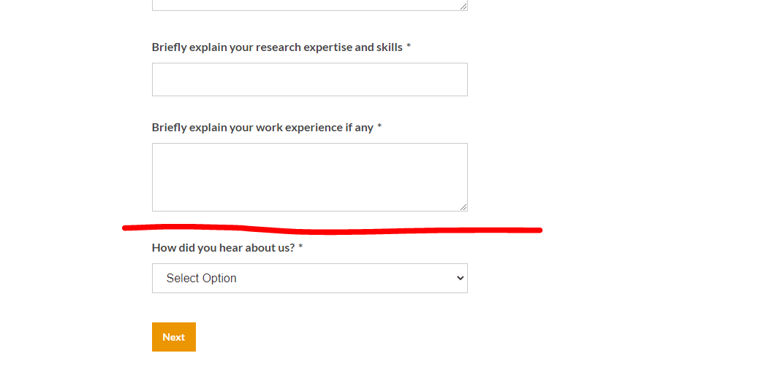
Please include a box on the ‘please specify’ option for people to enter information
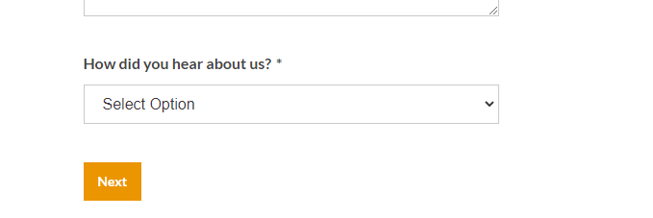
THIRD PAGE (CHECK OUT)
Please get rid of the below (billing address)
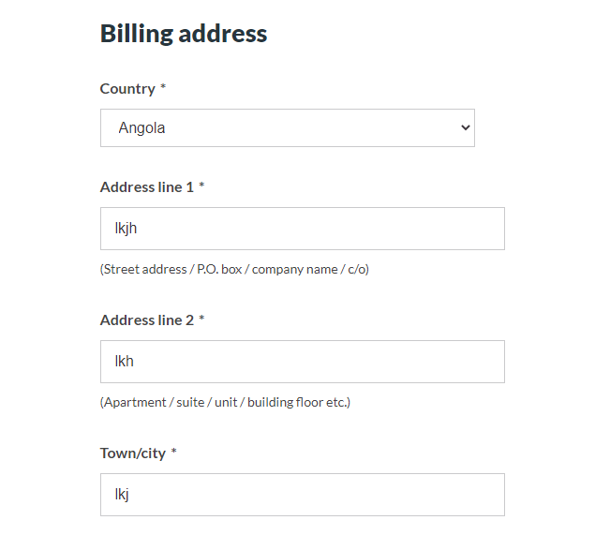
Paying for the course:
Right now people can only pay £1000 for the full amount of the course via PayPal. I also want people to be able to pay £200 for the deposit and then pay £800. Is there any way of providing the options to pay £200 (deposit), £800 (balance), £1000 (full)?
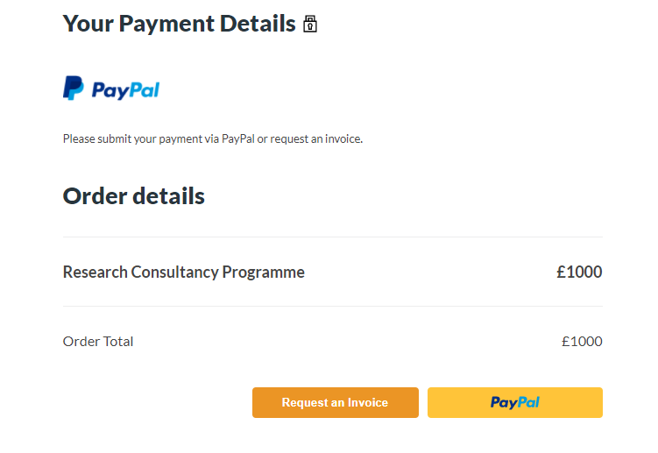
Please:
- rename the above ‘Request an Invoice’ button as ‘Pay by bank transfer’;
- add the text below about an alternative payment method so that it appears below the PayPal option on the webpage; and
- move the ‘Pay be Bank Transfer’ button to below the bank transfer information.

If you would prefer to pay via bank transfer, please transfer the relevant amount to the details below and click the ‘Pay by Bank Transfer’ button below to submit your registration form.
Bank details:
Code-Switch Consultants
Barclays Bank
Sort code 20-82-13
Bank account 43085945

Landing page

1) Banner
- -The banner needs to be bigger to cover the whole screen when people access the site using a monitor rather than a laptop.
- -Please change the colour of the initials to dark grey (see image below)
- -Include the sentence: Register for our programme and become a Code-Switch Associate Research Consultant above the sign up button (see image below) – This shouldn’t be in bold letters but normal text. The text colour should be dark grey.
- -The button ‘sign up’ replace with ‘register here’. This button should link to this page: https://codeswitchconsultants.com/consultancy-programme/
2) The three boxes:
- Please adjust the size of the three boxes ‘We provide services for’ (make them the same size)
- leave a blank space between the banner and the three boxes.
- And make sure that the buttons Read More are aligned.
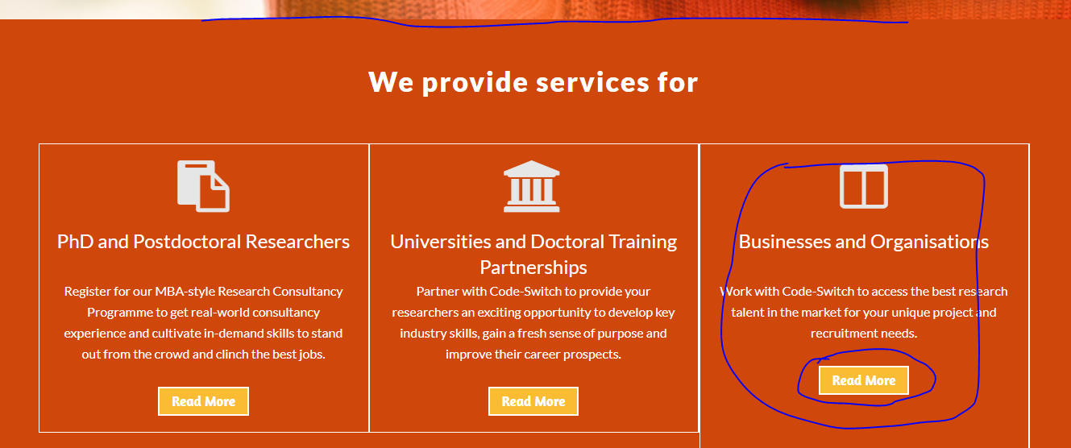
3) Please add these testimonials:
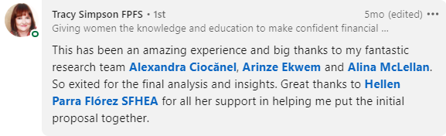
Link for Tracy Simpson’s comment https://www.linkedin.com/posts/hellenparraflorez_research-marketing-consultancyservices-activity-6714795379096866816-1_sL
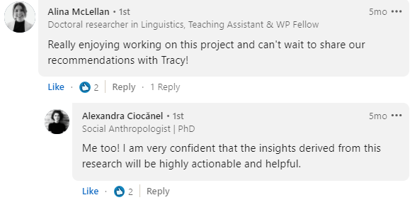
Link for comments above https://www.linkedin.com/posts/hellenparraflorez_research-marketing-consultancyservices-activity-6714795379096866816-1_sL
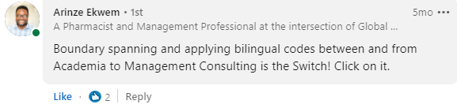
Link for comment above https://www.linkedin.com/posts/hellenparraflorez_research-marketing-consultancyservices-activity-6714795379096866816-1_sL
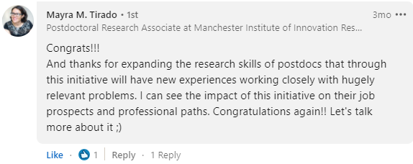
Link for comment above https://www.linkedin.com/posts/hellenparraflorez_research-consultancy-programme-autumn-2020-activity-6736689128332656640-Msm3
4) Include a button ‘Register here’ and another button next to it ‘Contact us’ See the image below
- Register here link: https://codeswitchconsultants.com/consultancy-programme/
- Contact us link: https://codeswitchconsultants.com/contact-us/
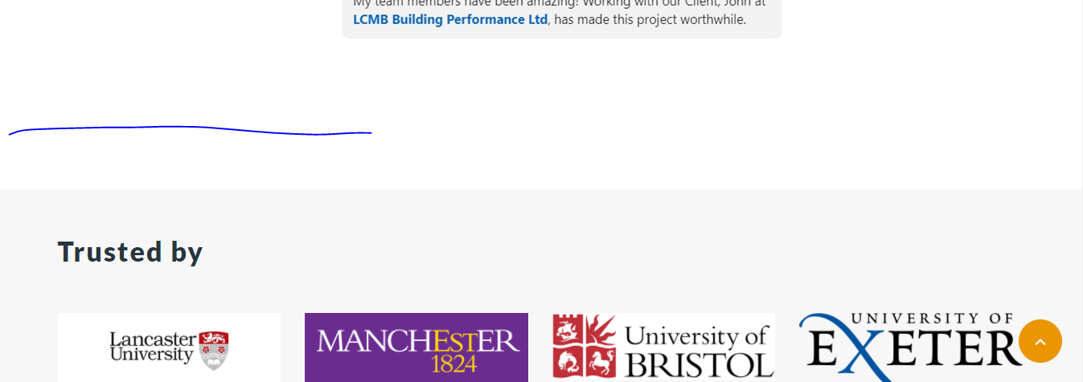

5) Logos
- Please align these logos
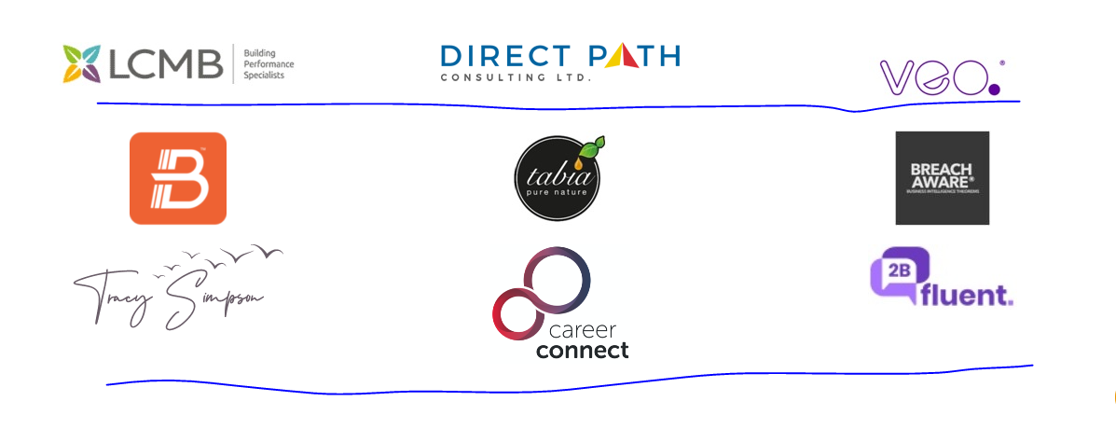
- Please add these two logos under the heading: Networks
*Please make sure that all logos appear in the same way in all pages.

6) Please add this after the last row of logos.
https://www.nousgroup.com/uk/
Use this project: https://codeswitchconsultants.com/2bfluent/
- It should say ‘Featured project’
- The title of the project is (in orange): Foreign language learning in secondary schools.
- The text below is: This project is exploring the needs of secondary schools in relation to the development of foreign language conversation skills...
- The button should say ‘See all projects’

Programme Details page
https://codeswitchconsultants.com/consultancy-programme/
1) The banner
Please add the this on the banner:
Replicate the same text and buttons that are on the landing page banner.
2) Payment box
Change date on the box to pay for the programme. The new dates are:
14 June 2021
Join by 14 May 2021 at 23:55
3) Add Testimonials slider after the ‘Meet the Team’ section.
4) Make sure that the logos section looks like the ones on the other pages.

Projects page
https://codeswitchconsultants.com/projects/
1) Please expand the image to cover the empty space (keep the same height)
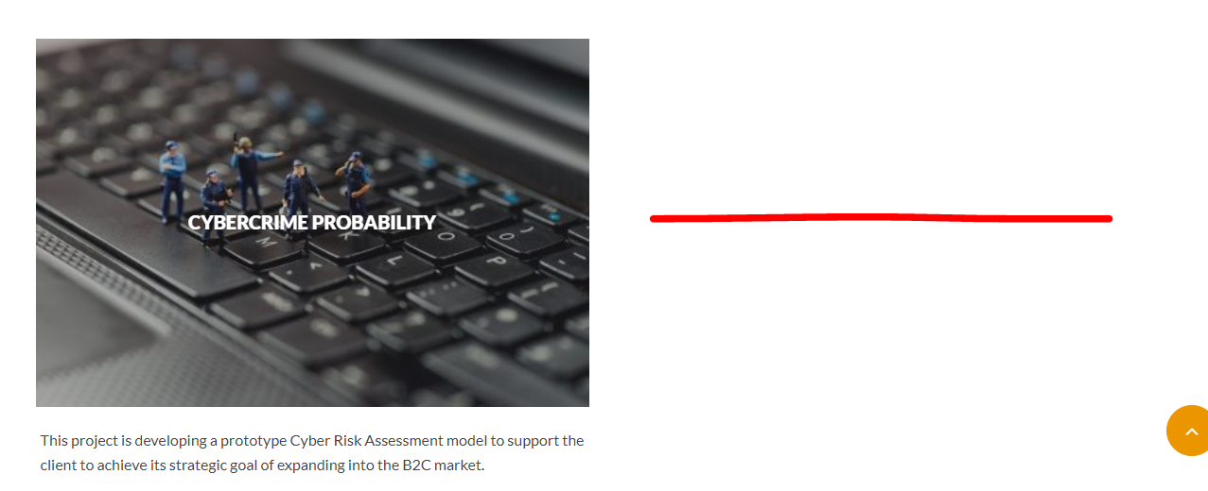

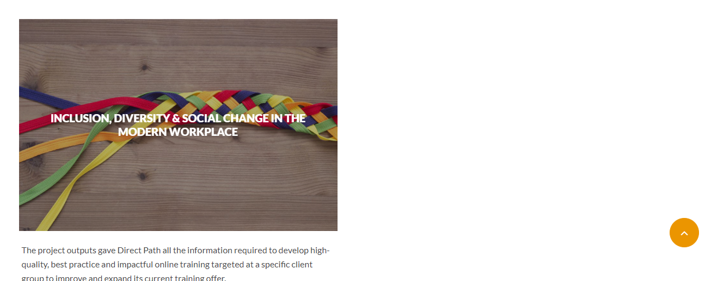
Make these two the same size as the other ones
