Feedback 1-7-22:
Please something we found on the current system setup (there may be more to be found later):
- Change customer’s account PW on live site goes to an empty page, and didn’t receive notification email message from the system, and the PW wasn’t changed after that as well:
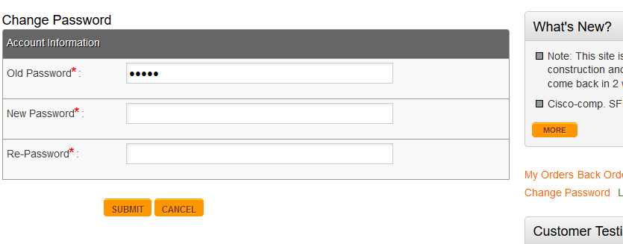

- Discount Code on the Shopping cart page does not work – see below, after apply the Code shown, there should be 20% discount deduction on the Final Total, but it shows no deduction at all – after clicking the APPLY NOW button.

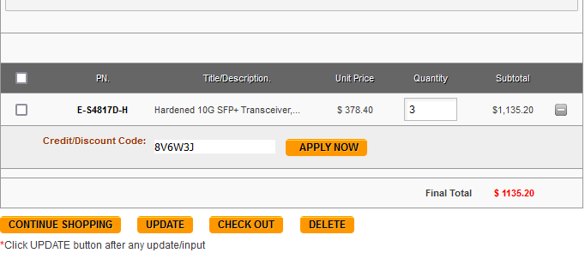

- The “Delete” button on Shopping cart page does not works – it shows an empty page after clicking the Delete button.

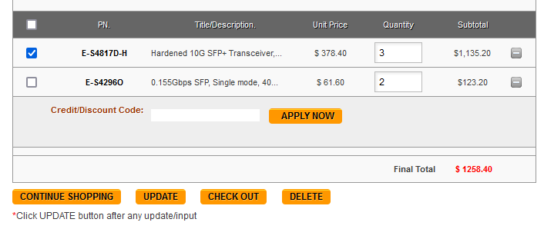

- Tax Rate on Backend Tax Manager page does not allow any value after decimal point (.). It seems the system does a decimal after the point, so if we make the value to 9.3, it saved to 9; and if we add a 9.7, it goes to 10, which is not the way it should go. Please allow the 2 numbers after decimal point (e.g. 8.35, or 10.06) for tax rates.

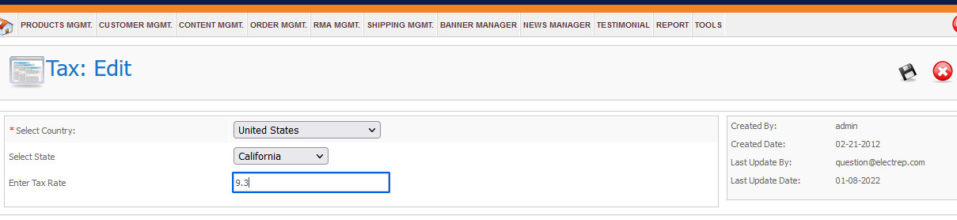

- We found that the Search Drag-down feature will only work on the 2nd search, which means if you get on our site on one of Browsers, and type a keyword (e.g. SFP) on Search box, the drag-down list won’t show up (see below SS1) and you could only get the results by hitting Enter key. The drag-down list will show up only when you try second keyword search (see below SS2). Please try it.
And we found the Drag-down list will show up on some of Browsers, and it is not working on Opera as an example.

SS1:

SS2:
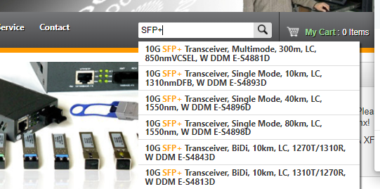

- PW Reset on Backend is still not working – the system does not sand “Reset” email to our mailbox (question@electreop.com) after clicked on Forget PW button - as reported before - although the screen said they already send an email (see below SS). However, by doing so, the existing PW for Admin had been changed, so that we cannot login to Backend any more with our original PW. Please check...
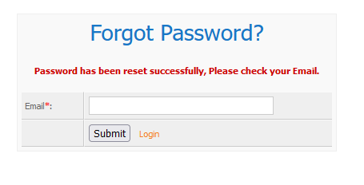
- Please do set up our site Shopping cart to my Paypal account (ggao@fhn-na.com), so that we could move to next major testing on Shopping cart and Paypal API connections.

