1. Remove State dropdown from location settings. When I select a Country, I should be able to select a City without selecting a State.

Expected behaviour -> Country, City
Current behaviour -> Country, State, City

URL - https://migrateway.com/test/wp-admin/admin.php?page=jobsearch-location-sett

Issue 1 – State dropdown is still displaying on User Register pages (Both Candidate & Employer)

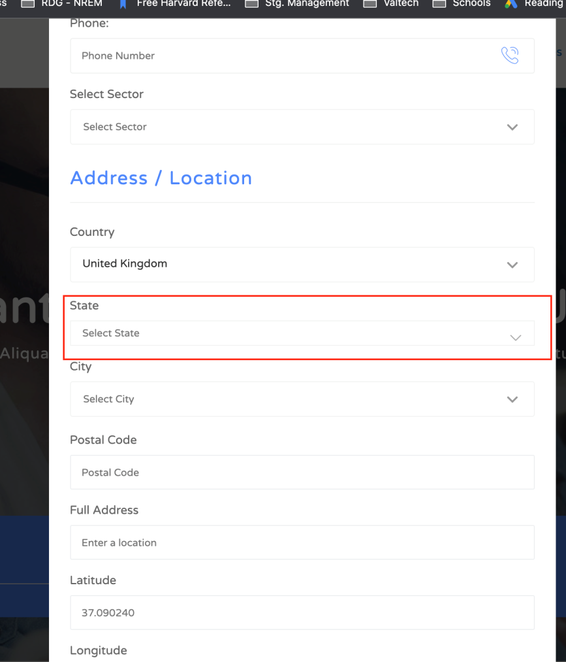

Issue 2 – State dropdown is still displaying on Location Editor page

https://migrateway.com/test/wp-admin/admin.php?page=jobsearch-location-sett-editor

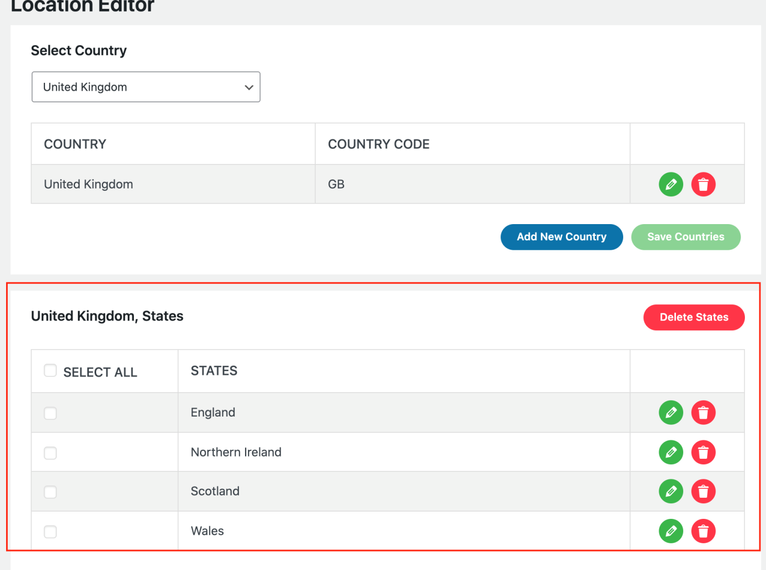

Issue 3 – State dropdown is still displaying on Dashboard Settings page for both Candidate and Employer

https://migrateway.com/test/user-dashboard/?tab=dashboard-settings

2. Add a custom field (supporting country) to Advance Search

Expected fields in Advance Search -> Sector, Location (country dropdown), Destination country (dropdown), Search button

Current fields in Advance Search -> Keyword, Location, Sector, Search button

URL - https://migrateway.com/test/ Advance Search

A Change Request – Can we do Advance Search as a new control called Advance Search 2 and keep original Advance Search as it is?

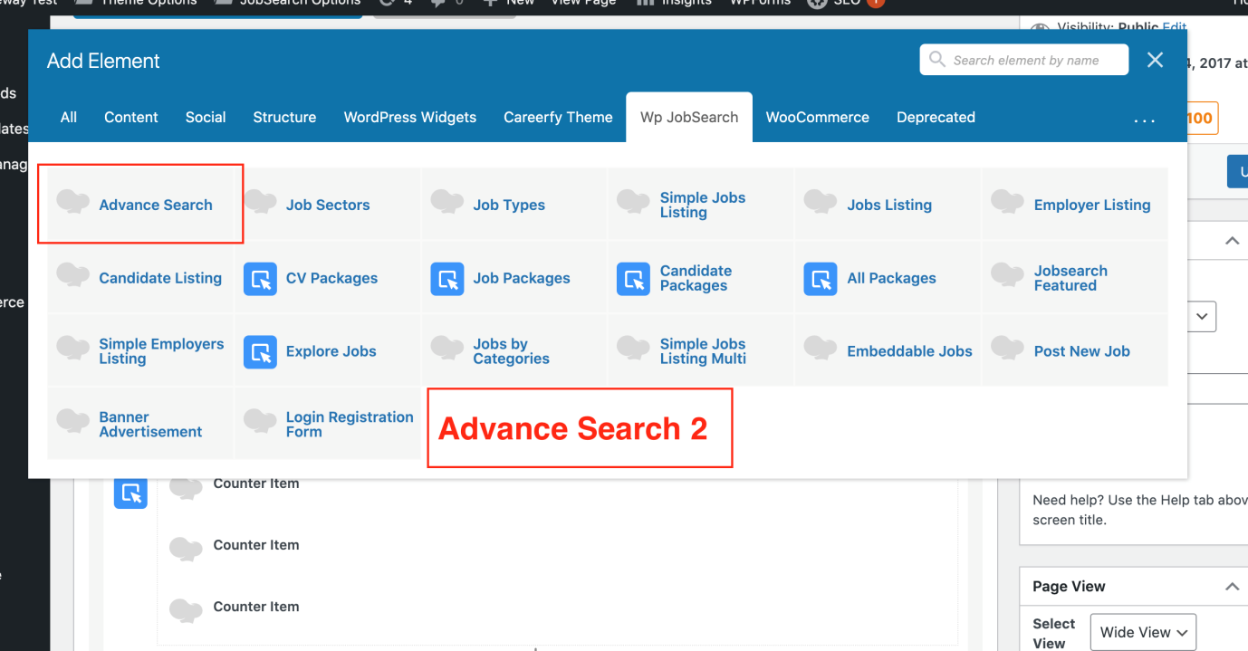

Issue 4 – Wrong values displaying for countries list. It should display countries from Location -> Countries list, not supporting courtiers for this dropdown.

Issue 5 - Wrong query string values for country and supporting country search

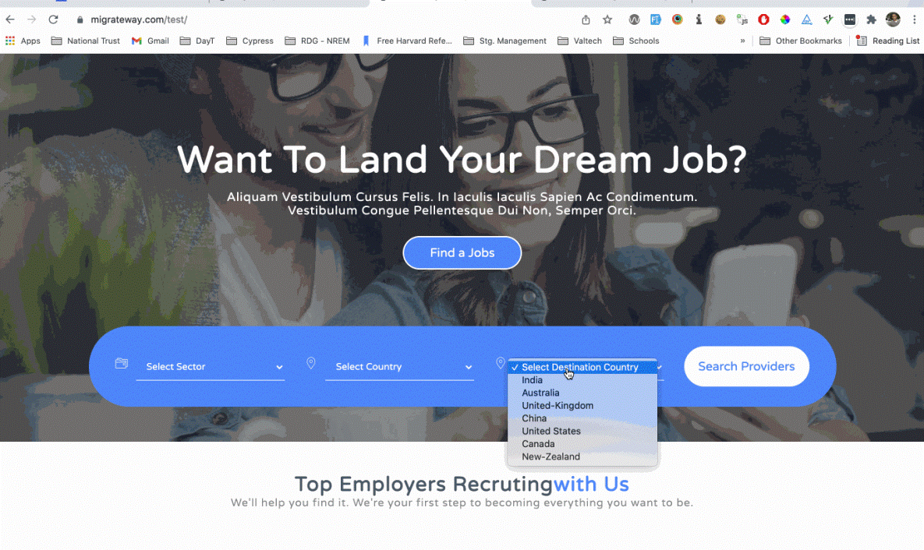

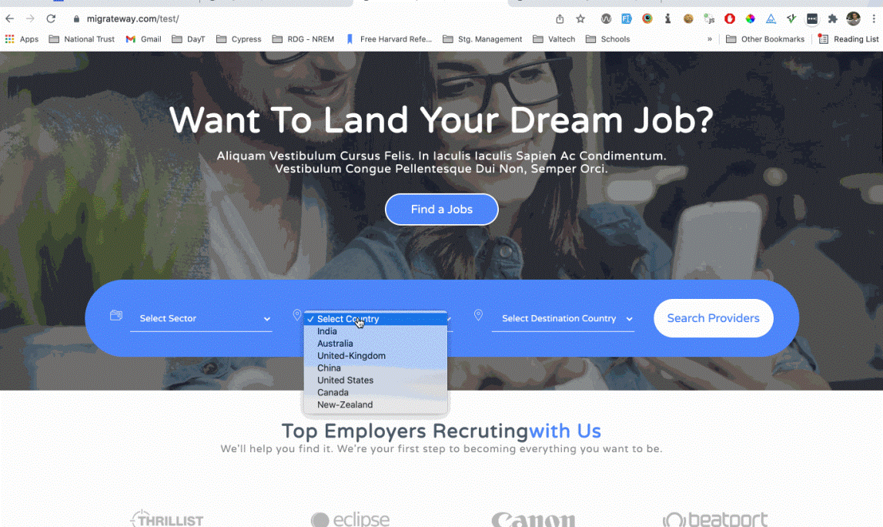
Issue 6 - Filter values are missing in Search Results page

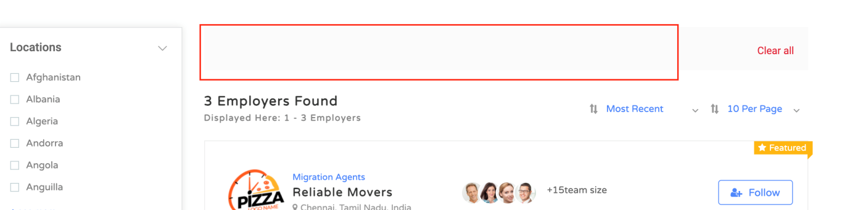

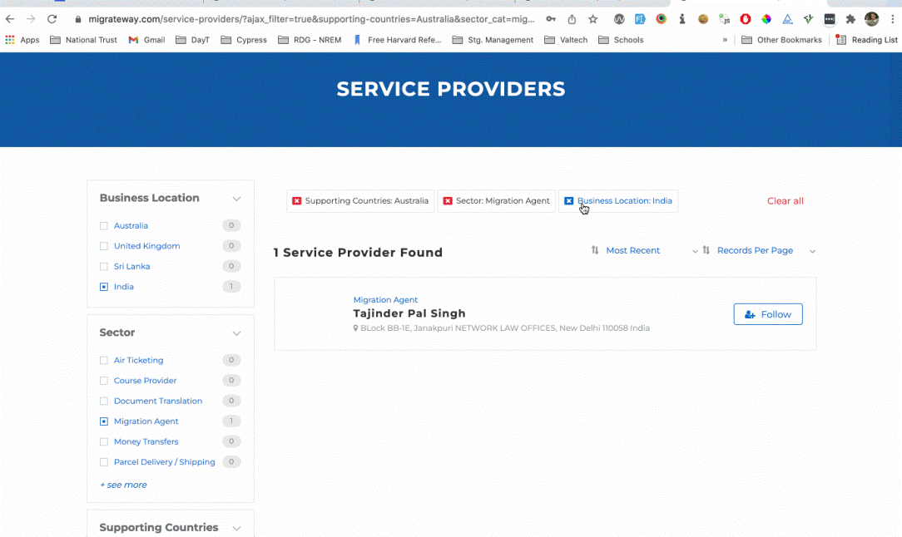

3. Search results page -> Display Location as a checklist (Countries only) and NOT as a dropdown.

Display only 6 highest locations with listings and then display “+ see more” link same as sectors check list

URL - https://migrateway.com/test/employer-listing/?search_title=&location=&sector_cat=

Issue 7 – Location checklist is missing the numbers for how many listings in that country

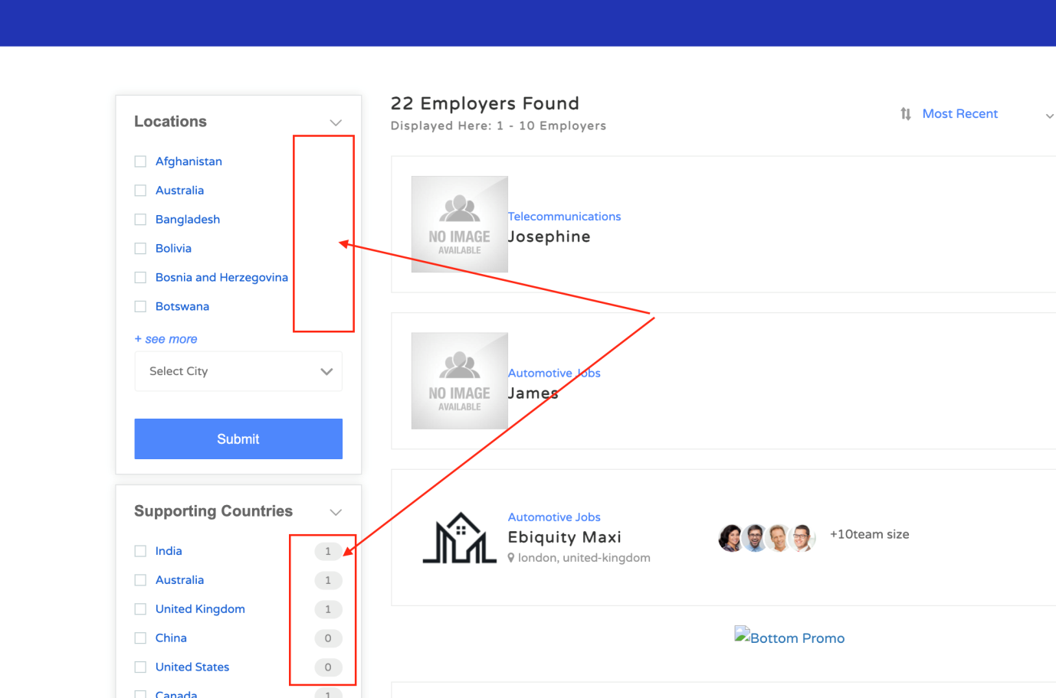

Issue 8 – Location checklist is not sorted by highest number of listings. So, the country is having highest number of listings should be displayed at the top

A change request – Can we please remove the City dropdown from Search Results page?

Issue 9 - Location filter is not working when I select a country
When I click on any country in the Location checklist the results page should refresh with filtering results to show results with that filter. It’s working fine in Supporting Countries field.

4. Add a “back to search results” link to employer details page to go back to results page. Just under the top navigation

URL - https://migrateway.com/test/employer/reliable-movers/

This is working fine

5. Change the Results page title and the header (H1 text) based on the selected values from Advance Search (done in #2 above)

Advance Search values:
Ex.
Sector – Migration Agents
Location – India
Supporting Countries – Australia
a. Expected page title and H1 – “Migration Agents to Australia from India – Migrateway”

b. If there is no location selected, then leave it as blank. ex. Migration Agents to Australia – Migrateway

c. If there is no supporting country selected, then change the word “from” to “in”
Ex. Migration agents in India

d. If there is no sector selected, then display the word “Service Providers” instead sector
ex. Services Providers in India

URL - https://migrateway.com/test/employer-listing/?sector_cat=migration-agents&supporting-countries=Australia&location_location1=India

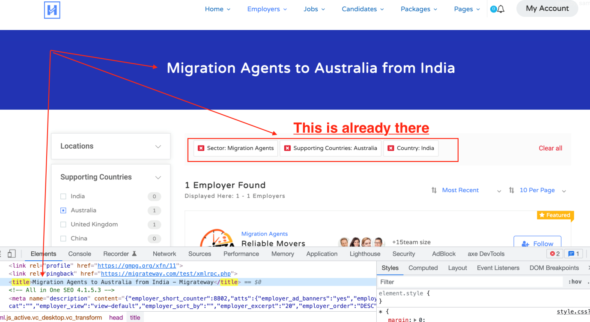

Issue 10 – Page title is not changed based on the search criteria

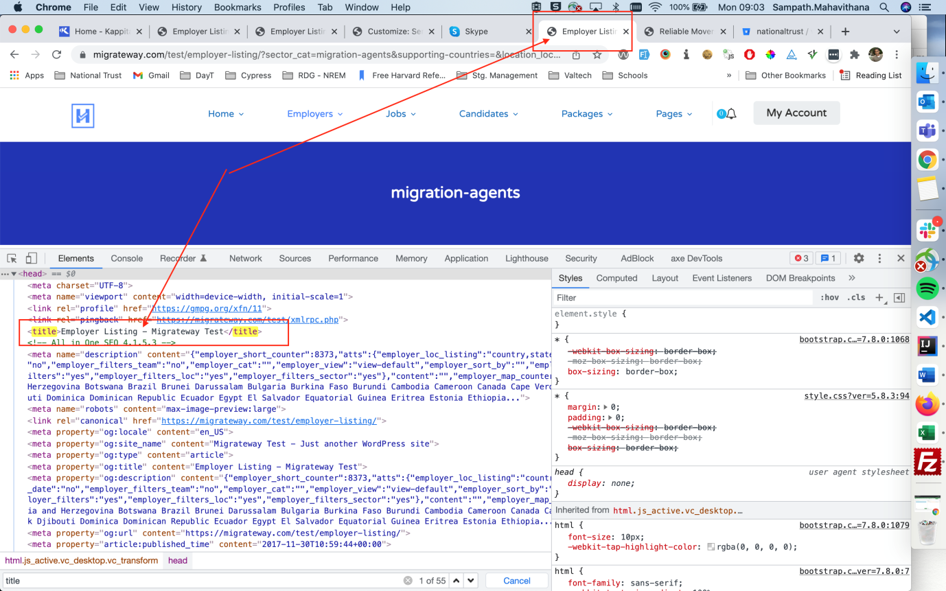

Issue 11 – Field Name should display not the keys for title and H1

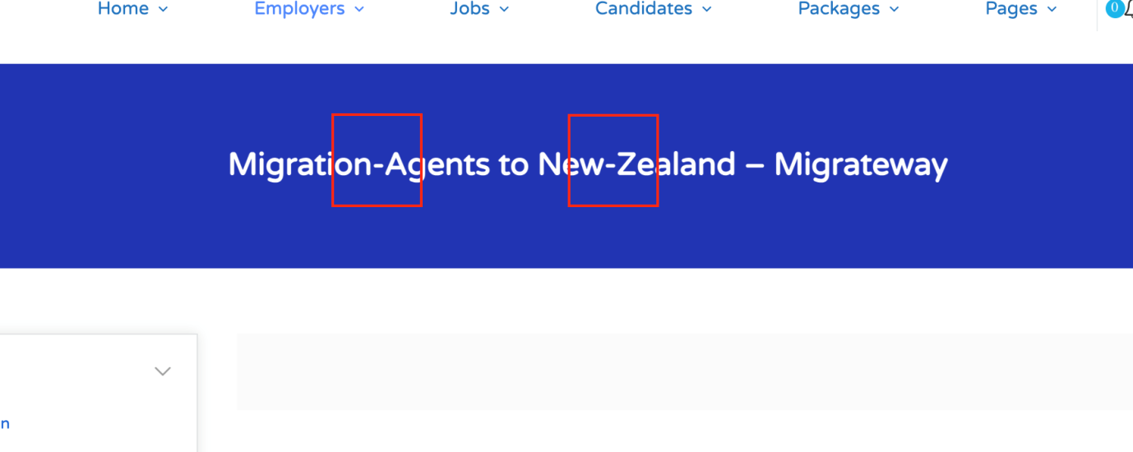

Issue 12 – Page title & H1 is not changing when I use filters on the page

Issue 13 - If there is no sector selected, then display the word “Service Providers” instead blank. ex. Services Providers in India

Please let me know the places in the code that you’ve changed after fixing above bugs. Thanks!

Important: I also need a document with all the files and the highlighted code that you’ll change for each modification as I need to do all these changes in another site.

1. Expected behaviour -> Country, City ( done )

code change files :
/wp-content/plugins/wp-jobsearch/modules/locations/include/location-settings.php

- https://prnt.sc/26cbb5o
- https://prnt.sc/26cb9xn

/wp-content/plugins/wp-jobsearch/modules/locations/include/location-ajax.php
- https://prnt.sc/26cbbzg
- https://prnt.sc/26cbbuw

/wp-content/plugins/wp-jobsearch/includes/classes/class-employer-filters.php
- https://prnt.sc/26cbbic

view: - https://prnt.sc/26cbipg
- https://prnt.sc/26cbibn

2. Add a custom field (supporting country) ( done )
/wp-content/plugins/careerfy-framework/shortcodes/vc-shortcodes/advance-search.php
//Location , Destination country ( added )
- https://prnt.sc/26ce85k

view: - https://prnt.sc/26cebry
- https://prnt.sc/26cebyc
- https://prnt.sc/26ceca1

4. Add a “back to search results” ( done )

code change file :
/wp-content/themes/careerfy-child/wp-jobsearch/detail-pages/employer/view3-employer.php
<!-- go back to result btn added -->
- https://prnt.sc/26cbhs0

view: - https://prnt.sc/26cbi39

3. Search results page -> Display Location as a checklist (Countries only) and NOT as a dropdown.
/wp-content/plugins/wp-jobsearch/includes/classes/class-employer-filters.php

- https://prnt.sc/26d5i66
- https://prnt.sc/26d5k3l

- https://prnt.sc/26d5ja1

5. Change the Results page title and the header (H1 text
- changes file path and line no

- file path /wp-content/plugins/careerfy-framework/includes/common-functions.php
- line no 1306 to 1333
- screen shot https://prnt.sc/26d61de

- changes screen shot in live site
https://prnt.sc/26d5l35

